Name

Mathematics Advanced Year 11
Radians

Book 1 |  | Version: 261007  Feedback:  https://MrDingMaths.com
Contents
Syllabus Content 2
Learning Intention 3

Syllabus Content
MAV-11-04 applies trigonometry to solve problems involving geometric shapes
Radians
- Recognise that both ratios $\frac{\text{arc length}}{\text{circumference}}$ and $\frac{\text{area of sector}}{\text{area of circle}}$ are equal to $\frac{θ}{\text{one revolution}}$ where $θ$ is the angle at the centre of a circle subtended by the arc
- Define the angle size of $θ$ in radian measure as the ratio $\frac{\text{arc length}}{\text{radius of a circle}}$
- Explain why $360°=2π$ radians and $\text{1 radian}=\frac{180}{π}\text{ degrees}$
- Convert between degrees and radians and find the exact sine, cosine and tangent ratios for integer multiples of $\frac{π}{6}$ and $\frac{π}{4}$
- Graph $y=sin x$, $y=cos x$ and $y=tan x$ over domains given in degrees or radians, showing intercepts with the $x$-axis and $y$-axis and any asymptotes, determine their domains and ranges, and period and amplitude where appropriate, and whether each is even or odd or neither
- Establish and use the formula $l=rθ$ for the length $l$ of arc subtending an angle $θ$ in radians at the centre of a circle of radius $r$
- Prove and use the formula $A=\frac{1}{2}r^{2}θ$ for the area of a sector with angle $θ$ in radians at the centre of a circle of radius $r$
- Solve problems involving arc lengths and areas of major and minor sectors and segments

Radians

- Radians
- Ancient Babylonians invented degrees as an arbitrary unit.
To connect degrees to their circular origin, we use radians.
- A radian is the angle formed when an arc equals exactly 1 radius in length.
- Radians represent a dimensionless ratio comparing arc length to radius.
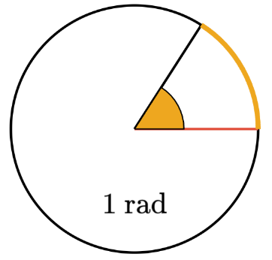
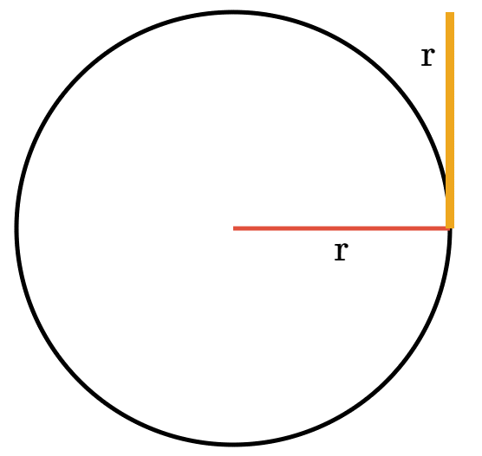
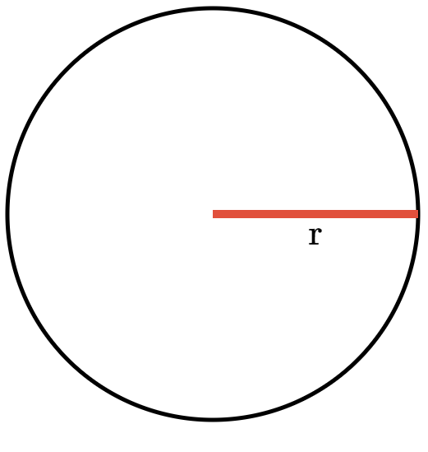
$180°=π$ radians
$360°=2π$ radians
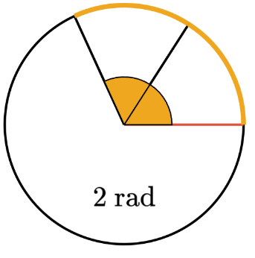
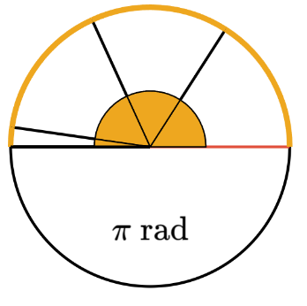
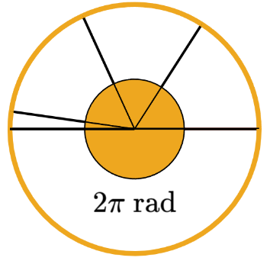
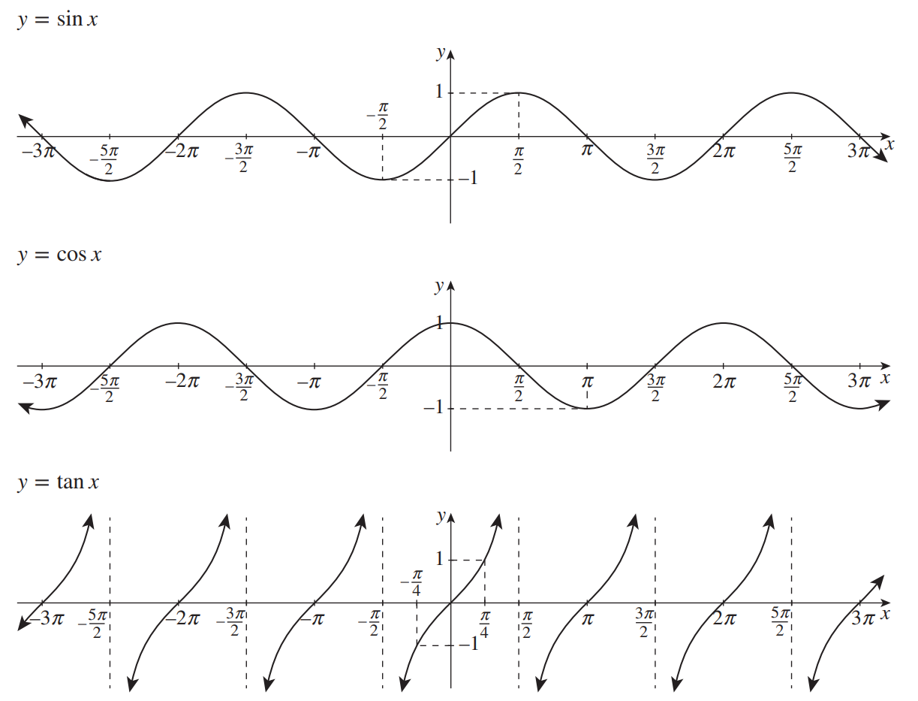

- Converting Radians and Degrees
- If an angle doesn’t have a degree symbol, assume it is in radians.
$π$ rad = $180°$
radians to degrees:  $$×\frac{180°}{π}$$ |  | degrees to radians:  $$×\frac{π}{180°}$$

- Example Convert degrees to radians
$$60°$$  $$60×\frac{π}{180} \\ =\frac{π}{3}$$ | $$495°$$  $$495×\frac{π}{180} \\ =\frac{11π}{4}$$

- Guided Practice
Convert to radians.
- $30°$  `$\frac{π}{6}$ | - $135°$  $$\frac{3π}{4}$$ | - $270°$  $$\frac{3π}{2}$$

- Example Convert radians to degrees
$$\frac{π}{6}$$  $$\frac{π}{6}×\frac{180}{π} \\ =30°$$ | $$0.3$$  $$0.3×\frac{180}{π} \\ ≈17°$$

- Guided Practice
Convert to radians.
- $\frac{3π}{4}$  135$°$ | - $20$  1146 | - $4π$  720$°$

- Key Ideas
- $π$ radians is …………$°$

Foundation
- Convert to degrees.
- $π$  180° | - $2π$  360° | - $3π$  540° | - $4π$  720° | - $5π$  900°
- $\frac{π}{2}$  90° | - $\frac{3π}{2}$  270° | - $\frac{π}{3}$  60° | - $\frac{2π}{3}$  120° | - $\frac{4π}{3}$  240°
- $\frac{5π}{3}$  300° | - $\frac{π}{4}$  45° | - $\frac{3π}{4}$  135° | - $\frac{5π}{4}$  225° | - $\frac{7π}{4}$  315°
- $\frac{π}{6}$  30° | - $\frac{5π}{6}$  150° | - $\frac{7π}{6}$  210° | - $\frac{11π}{6}$  330°

- Convert to radians in terms of $π$.
- $30°$  $$\frac{π}{6}$$ | - $45°$  $$\frac{π}{4}$$ | - $60°$  $$\frac{π}{3}$$ | - $90°$  $$\frac{π}{2}$$ | - $120°$  $$\frac{2π}{3}$$
- $135°$  $$\frac{3π}{4}$$ | - $150°$  $$\frac{5π}{6}$$ | - $180°$  $$π$$ | - $210°$  $$\frac{7π}{6}$$ | - $225°$  $$\frac{5π}{4}$$
- $240°$  $$\frac{4π}{3}$$ | - $270°$  $$\frac{3π}{2}$$ | - $300°$  $$\frac{5π}{3}$$ | - $315°$  $$\frac{7π}{4}$$ | - $330°$  $$\frac{11π}{6}$$

- Convert to degrees.
- $\frac{π}{2}$  90° | - $\frac{π}{3}$  60° | - $\frac{π}{4}$  45° | - $\frac{2π}{3}$  120° | - $\frac{5π}{3}$  300°
- $\frac{7π}{6}$  210° | - $\frac{4π}{3}$  240° | - $\frac{13π}{6}$  390° | - $\frac{3π}{2}$  270° | - $\frac{5π}{6}$  150°
- $\frac{11π}{6}$  330° | - $\frac{7π}{6}$  210° | - $\frac{2π}{5}$  72° | - $\frac{11π}{8}$  247.5° | - $\frac{17π}{10}$  306°

- Convert to radians in terms of $π$.
- 20°  $$\frac{π}{9}$$ | - 22.5°  $$\frac{π}{8}$$ | - 36°  $$\frac{π}{5}$$ | - 100°  $$\frac{5π}{9}$$ | - 112.5°  $$\frac{5π}{8}$$

Exact Values in Radians

- Exact Values of the Trigonometric Ratios in Radians
 | $$\frac{π}{6}$$ | $$\frac{π}{4}$$ | $$\frac{π}{3}$$ | $$\frac{π}{2}$$ | $$\frac{π}{6}$$
$$\sin{θ}$$ | 0 | $$\frac{1}{2}$$ | $$\frac{1}{\sqrt{2}}$$ | $$\frac{\sqrt{3}}{2}$$ | 1
$$\cos{θ}$$ | 1 | $$\frac{\sqrt{3}}{2}$$ | $$\frac{1}{\sqrt{2}}$$ | $$\frac{1}{2}$$ | 0
$$\tan{θ}$$ | 0 | $$\frac{1}{\sqrt{3}}$$ | $$1$$ | $$\sqrt{3}$$ | undefined

- You must memorise these exact values and be able to recall them quickly.

- Radians in a Calculator
- Your calculator is able calculate trigonometric functions that use radian measure.
- Always be aware of whether your calculator is in degrees mode or radians mode.
- If your answer is very small, or very close to 1, it is probably in the incorrect mode.

Casio FX-82 AU    1.  2. Select Rad  You should have a R on the top of the screen  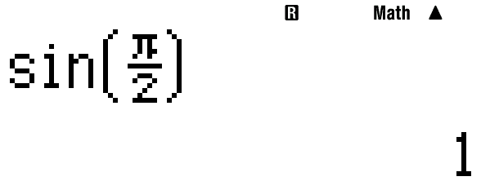 |   Casio FX-8200 AU  1. Settings  2. Calc settings  3. Angle unit  4. Select Radian  You should have a R on the top of the screen

- Evaluate Trigonometric functions in radians
Evaluate, using either your knowledge of exact values or a calculator.
All angle units are in radians. Round to 2 d.p. when it is not a known exact value.
- $\cos{\frac{π}{6}}$ | - $\tan{\frac{π}{3}}$ | - $\sin{\frac{π}{4}}$
- $\sin{4}$ | - $\tan{1.3}$ | - $\cos{0.5}$

- Angles of Any Magnitude using Radians
- Determine the quadrant of the angle and sketch the angle.
- Rewrite the function with the reference angle
- Use ASTC to determine if the answer will be positive or negative.

- Example Find exact value of a trigonometric function in radians
Find the exact value of these trigonometric functions.
$$\sin{\frac{5π}{4}}$$  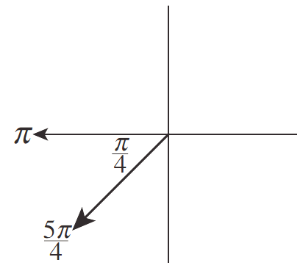  1.  $$2. \sin{\frac{5π}{4}}=-\sin{\frac{π}{4}} \\ 3. =-\frac{1}{\sqrt{2}}$$ | $$\cos{\frac{11π}{6}}$$  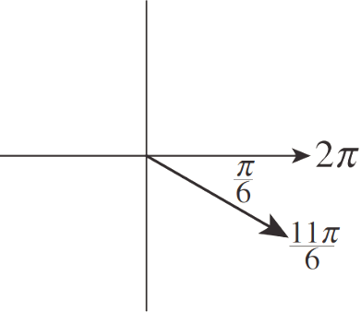  1.  $$2. \cos{\frac{11π}{6}}=\cos{\frac{π}{6}} \\ 3. =\frac{\sqrt{3}}{2}$$

- Guided Practice
Find the exact value of these trigonometric functions
- $\sin{\frac{2π}{3}}$ | - $\tan{\frac{7π}{6}}$
- $\cos\left(-\frac{π}{6}\right)$ | - $\tan\left(\frac{5π}{4}\right)$

Foundation
- Find the exact value of:
- $\sin{\frac{π}{6}}$  $$\frac{1}{2}$$ | - $\sin{\frac{π}{4}}$  $$\frac{1}{\sqrt{2}}$$ | - $\cos{\frac{π}{6}}$  $$\frac{\sqrt{3}}{2}$$ | - $\tan{\frac{π}{3}}$  $$\sqrt{3}$$
- $\tan{\frac{π}{4}}$  $$1$$ | - $\cos{\frac{π}{3}}$  $$\frac{1}{2}$$ | - $\tan{\frac{π}{6}}$  $$\frac{1}{\sqrt{3}}$$ | - $\sin{\frac{π}{3}}$  $$\frac{\sqrt{3}}{2}$$
- $\tan{\frac{π}{3}}$  $$\sqrt{3}$$ | - $\sin{\frac{π}{3}}$  $$\frac{\sqrt{3}}{2}$$ | - $\sin{\frac{π}{2}}$  1 | - $\tan{\frac{π}{2}}$  undefined
- $1-\cos^{2}{\frac{π}{4}}$  $$\frac{1}{2}$$ | - $\tan{\frac{π}{3}}\cos{\frac{π}{3}}$  $$\frac{\sqrt{3}}{2}$$ | - $\sqrt{1+\tan^{2}{\frac{π}{4}}}$  $$\sqrt{2}$$

- With your calculator in radians mode, evaluate to 2 d.p. the following:
- $\sin{1}$  0.84 | - $\cos{2}$  $$-0.42$$ | - $\tan{3}$  $$-0.14$$
- $\sin{0.7}$  $$0.64$$ | - $\cos{1.23}$  $$0.33$$ | - $\tan{5.678}$  $$-0.69$$

- Using your knowledge of angles of any magnitude, find the exact value of:
- $\sin{\frac{2π}{3}}$  $$\frac{\sqrt{3}}{2}$$ | - $\cos{\frac{2π}{3}}$  $$-\frac{1}{2}$$ | - $\cos{\frac{5π}{6}}$  $$-\frac{\sqrt{3}}{2}$$ | - $\tan{\frac{4π}{3}}$  $$\sqrt{3}$$
- $\tan{\frac{3π}{4}}$  $$-1$$ | - $\cos{\frac{5π}{3}}$  $$\frac{1}{2}$$ | - $\sin{\frac{5π}{4}}$  $$-\frac{1}{\sqrt{2}}$$ | - $\tan{\frac{7π}{6}}$  $$\frac{1}{\sqrt{3}}$$
- $\cos{\frac{3π}{4}}$  $$-\frac{1}{\sqrt{2}}$$ | - $\sin{\frac{5π}{6}}$  $$\frac{1}{2}$$ | - $\tan{\frac{7π}{4}}$  $$-1$$ | - $\cos{\frac{4π}{3}}$  $$-\frac{1}{2}$$
- $\sin{\frac{5π}{3}}$  $$-\frac{\sqrt{3}}{2}$$ | - $\cos{\frac{13π}{6}}$  $$\frac{\sqrt{3}}{2}$$ | - $\tan{\frac{11π}{3}}$  $$-\sqrt{3}$$ | - $\sin{\frac{23π}{6}}$  $$-\frac{1}{2}$$

Development
- Complete the table with exact values.
$θ$ | 0 | $$\frac{π}{2}$$ | $$π$$ | $$\frac{3π}{2}$$ | $$2π$$
$$\sin{θ}$$ | 0 | 1 | 0 | 1 | 0
$$\cos{θ}$$ | 1 | 0 | 1 | 0 | 1
$$\tan{θ}$$ | 0 | undefined | 0 | undefined | 0

The 3 graphs below show the sketches of $y=\sin{x}$, $y=\cos{x}$, $y=\tan{x}$ in domain $x∈\left[0,2π\right]$.
Identify the graphs then label all key relevant points using your tables .

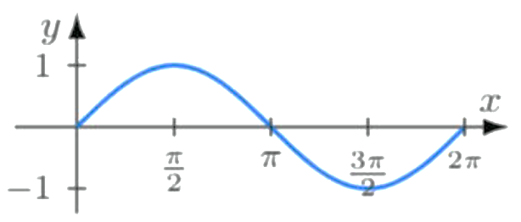
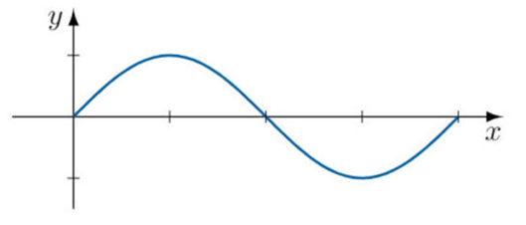
$y=\sin{x}$

$$y=\tan{x}$$
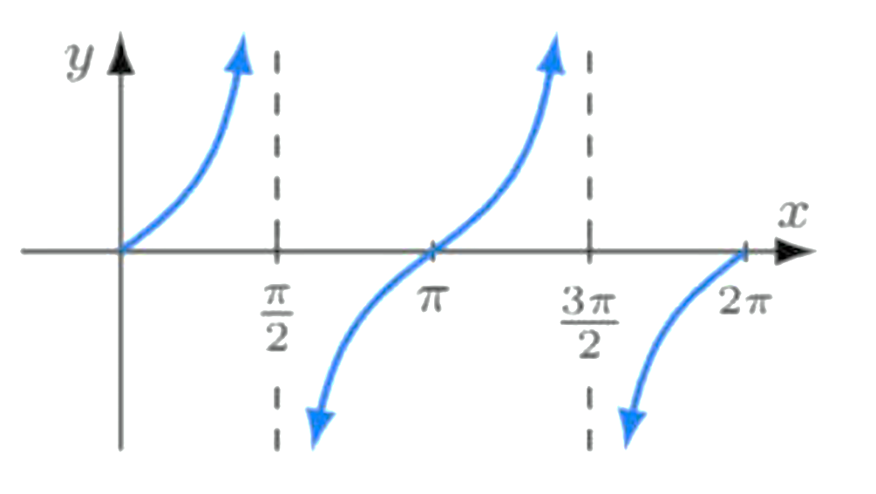
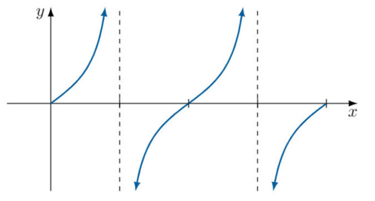

$$y=\cos{x}$$
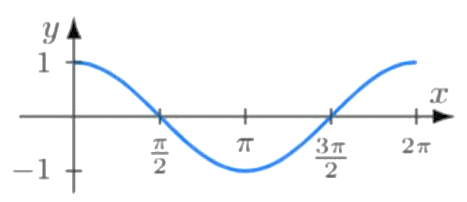
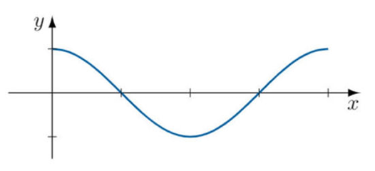

- 2013 HSC Advanced Band 5
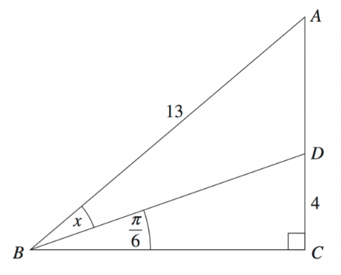
Using the sine rule, or otherwise, find the exact value of $\sin{x}$.
Approach: Use sine rule in triangle $ΔADB$ by finding $∠ADB$ and AD first.
$$∠BDC=π-\frac{π}{2}-\frac{π}{6}=\frac{π}{3}$$
$$∴∠ADB=\frac{2π}{3}$$
$$\tan{\frac{π}{6}}=\frac{4}{BC}; BC=4\sqrt{3}$$
Using Pythagoras in $ΔABC,$
$$AC=\sqrt{{13}^{2}-{\left(4\sqrt{3}\right)}^{2}}=11$$
$$∴AD=AC-DC=7$$
Using sine rule:
$$\frac{\sin{x}}{7}=\frac{\sin{\frac{2π}{3}}}{13}$$
$$\sin{x}=\frac{7\sin{\frac{2π}{3}}}{13}=\frac{6\sqrt{3}}{26}$$

Arc Length and Sector Area using Radians

- Arc Length Formula
- The arc length formula using radians is much “neater”.
This neatness is essential in the future in trigonometric calculus.
Arc length using degrees  $$l=\frac{θ}{360°}×2πr$$ | Arc length using radians  $$l=rθ$$ | 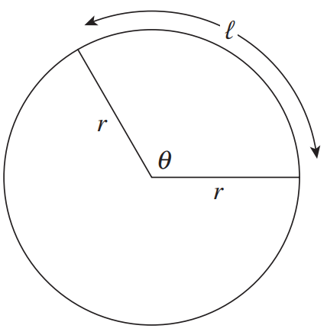

- Example Calculate arc length using radians
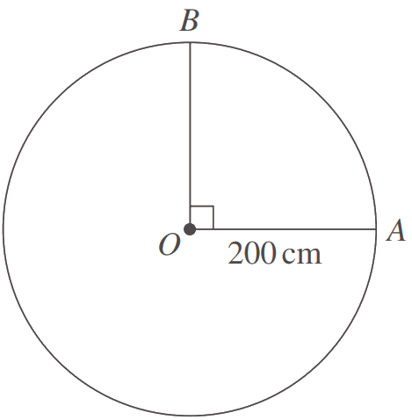  What is the length of an arc subtending a right angle at the centre of a circle of radius 200 cm?  $l=rθ$  $$=200×\frac{π}{2}$$  $=100π$cm | 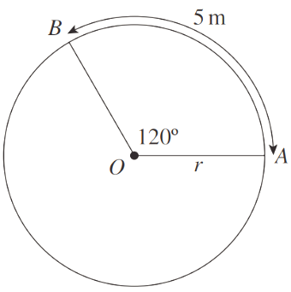  What is the radius of a circle in which an arc of length 5m subtends an angle of 120° at the centre?  $l=rθ$  $$5=r×\frac{2π}{3}$$  $$\frac{15}{2π}=r$$

- Guided Practice
- Find the arc length subtending an angle of $\frac{π}{6}$ at the centre of circle of radius 18 cm  $3π$ cm | - A circle has radius 6 cm. Find the length of an arc of this circle that subtends an angle at the centre of 2 radians.  $12$ cm

- Sector Area Formula
- The arc length formula using radians is much “neater”.
This neatness is essential in the future in trigonometric calculus.
Sector area using degrees  $$A=\frac{θ}{360°}×πr^{2}$$ | Sector area using radians  $$A=\frac{1}{2}r^{2}θ$$ | 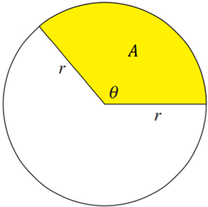

- Example Calculate sector area using radians
What is the area of a sector subtending an angle of 45° at the centre of a circle of radius 40m?  $$A=\frac{1}{2}r^{2}θ$$  $$=\frac{1}{2}×{40}^{2}×\frac{π}{4}$$  $=200π$m² | A circular cake has radius 12 cm. What is the angle subtended at the centre by a sector of area 100 cm²? Answer to the nearest degree.  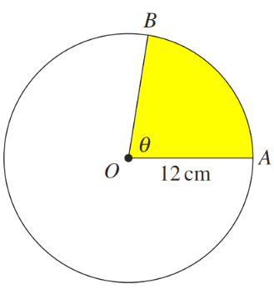  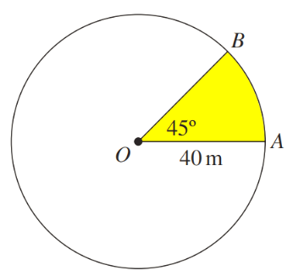  $$A=\frac{1}{2}r^{2}θ$$  $$100=\frac{1}{2}×{12}^{2}×θ$$  $$\frac{200}{{12}^{2}}=θ$$  $$80°≈θ$$

- Guided Practice
- What is the area of a sector subtending an angle of $\frac{π}{4}$ at the centre of a circle of radius 4 cm?  2$π$ cm² | - A circle has radius 8 cm. Find the area of a sector of this circle that subtends an angle at the centre of 3 radians.  96 cm²

Foundation
- A sector has radius 5 cm. If the angle subtended at the centre is 2 radians, find the:
- Arc length  10 cm | - Area of the sector  25 cm²

- A sector has radius 6 cm. If the angle subtended at the centre is 120$°$, find in exact form:
- Arc length  $4π$ cm | - Area of the sector  $12π$ cm²

- A sector has radius 3 cm. If the angle subtended at the centre is 150$°$, find in exact form:
- Arc length  $$\frac{5π}{2} cm$$ | - Area of the sector  $$\frac{15π}{4} {cm}^{2}$$

- A sector has radius 10 cm. If the arc length is 8cm, find in exact form the angle subtended at the centre in radians.

$$\frac{4}{5}$$
- A sector has radius 5 cm and area $10π$ cm². Find the arc length of the sector in exact form.

$4π$ cm

Development
- The sector has an area of $15π$ cm². What is the value of $r$?
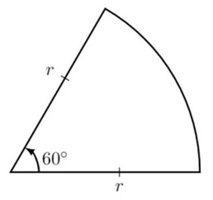

$3\sqrt{10}$ cm
- A car windscreen wiper traces out an area ABCD where AB and CD are arcs of circles with centre O and radii 30 cm and 15 cm respectively. $∠AOB=120°$.
Find the area of ABCD in exact form.
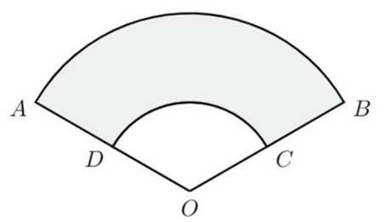

$225π$ cm²
- Let the sector subtended by angle $θ$ have area 625$π$ cm².
  - Find the value of $r$ if $θ=$ $\frac{π}{5}$.
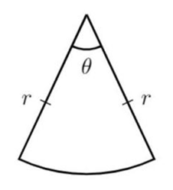
  - Find the value of $θ$ if $r=8$ cm.

$a) 25\sqrt{10}$ cm $b)$ $\frac{625}{32}$ $π$
- A sector subtending $72°$ is cut from a circle of radius 4 cm. Find the
  - shaded area.
  - length of remaining arc.
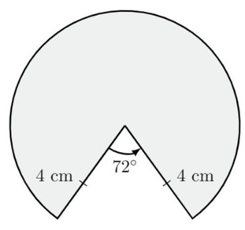

$$a)\frac{64}{5}π cm^{2} b)\frac{32}{5}π cm$$
- A chord of length 5 cm is drawn in a circle with centre O and radius $2\sqrt{2}$ cm.
  - Use cosine rule to find $∠AOB$ is radians, correct to 3 d.p.
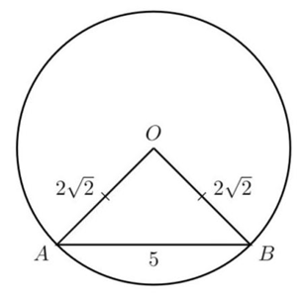
  - Hence find the arc length cut off by the chord, correct to 2 d.p.

a) 2.168 b) 6.13 cm
- The diagram below shows an arc $PQ$ of length 40 cm, subtended by some angle in a circle with radius 70 cm. Find:
  - $∠POQ$ in radians.
  - Area of sector $POQ.$
  - Area of $ΔPOQ$ to the nearest cm²
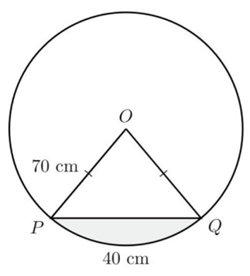
  - Shaded area correct to nearest cm²

a) $\frac{4}{7}$
b) 1400 cm²
c) 1325 cm²
d) 75 cm²
- Triangle ABC is equilateral with side length 2 cm. Circular arcs AB, BC and CA have centres C, A and B respectively. Answer each part in exact form.
  - Find the length of the arc AB.
  - Find the area of the sector CAPBC.
  - Find the length of the perimeter APBQCRA.
  - Find the area of △ABC and hence find the area enclosed by the perimeter APBQCRA.
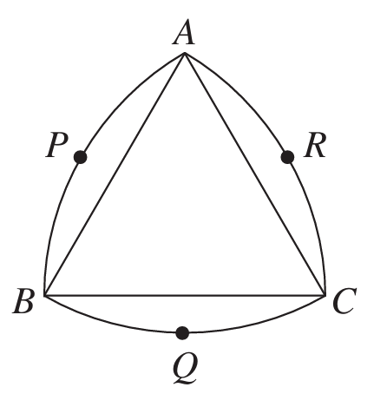

$$a)\frac{2π}{3} cm$$
$$b)\frac{2π}{3} cm^{2}$$
$$c) 2π cm$$
$$d) \sqrt{3} cm^{2}, 2\left(π-\sqrt{3}\right) {cm}^{2}$$
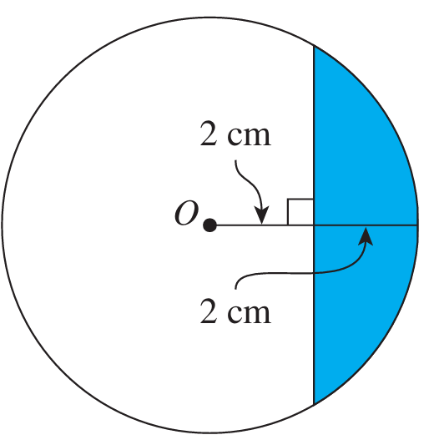
- Find the exact area of the shaded region of the circle shown in the diagram.

$$\frac{4}{3}\left(4π-3\sqrt{3}\right) {cm}^{2}$$
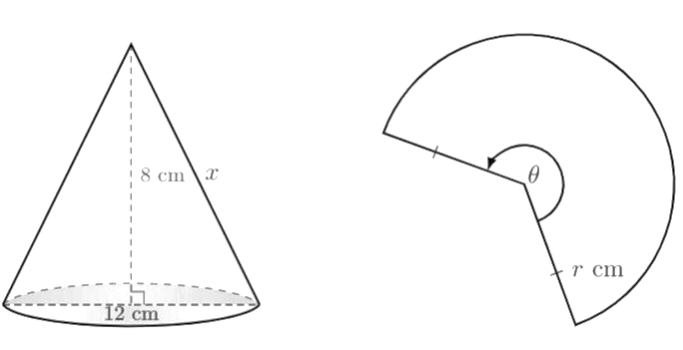
- A cone is made from a sector with radius $r$ and angle $θ$ by joining the two straight-line edges together.

  - Find the radius of the cone.
  - Hence find the value of $r$. hint: what does $r$ become on the cone?
  - Find the arc length of the sector. hint: what does the arc length become on the cone?
  - Find the sector angle $θ$ in radians.

a) 6 cm
b) 10 cm
c) 12$π$ cm
d) $\frac{6π}{5}$
- An athlete runs at a steady 4 m/s around a circular track of radius 300 metres. She runs clockwise, starting at the southernmost point.
  - What distance around the track has she run after 3 minutes?
  - What angle does this distance subtend at the centre?
  - How far is she from her start, in a direct line across the field, correct to the nearest 0.01 metre?
  - What is her true bearing from the centre then, correct to the nearest minute?
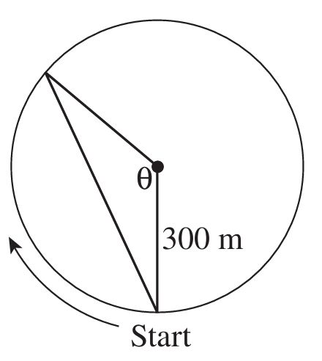

$a)$720 metres
b) 2.4 radians
c) 559.22 metres
d) 317° 31’ T
- The sector OAB has an area of $\frac{π}{2}$ cm². The arc length is $\frac{π}{4}$ cm.
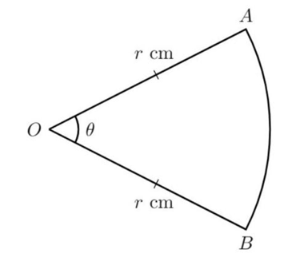
By solving simultaneously, find the exact values of $r$ and $θ$

$$r=4 cm, θ=\frac{π}{16}$$

- The area of a sector is $\frac{3π}{10}$ cm² and the arc length cut off by the sector is $\frac{π}{5}$ cm.
Find the exact value of $r$ and $θ$.

$$r=3 cm, θ=\frac{π}{15}$$
- AC and AD are equal tangents to the circle of radius 5 cm.
The point A is 13 cm from the centre B.
BC is perpendicular to AC and BD is perpendicular to AD.
  - Find $∠ABC$ in radians, to 3 d.p.
  - Find minor arc CD, to 2 d.p.
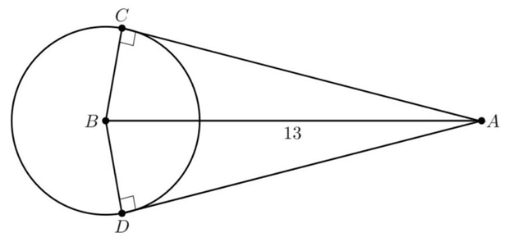
  - Find major arc CD, to 2 d.p.

a) 1.176
b) 11.76
c) 19.66

- A straight road was constructed to cut a dangerous bend on a country road. It was found that the bend was part of an arc of radius 180 m and the straight road was 240 m long.
  - Use cosine rule to find $θ$ in radians, to 2 d.p.
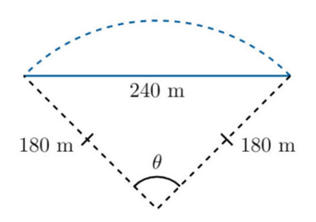
  - Find the distance by which the old road was shortened, to the nearest metre.

a) 1.46
b) 23 m

- A bicycle wheel of radius 36 cm turns through an angle of $\frac{2π}{3}$ radians in 0.16 seconds. At what speed is the bicycle being ridden, in metres per minute? Answer in exact form.

Speed = distance $÷$ time
$$=\frac{0.36×\frac{2π}{3} metres}{\left(\frac{0.16}{60}\right) minutes}=90π metres/min$$

- 2004 HSC Advanced Band 4
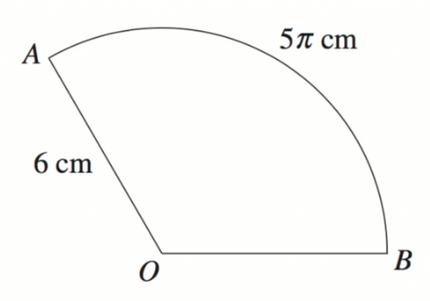
Calculate the exact area of sector $AOB$

$$l=rθ$$
$$5π=6θ$$
$$θ=\frac{5π}{6}$$
$$A=\frac{1}{2}r^{2}θ$$
$$=\frac{1}{2}{\left(6\right)}^{2}\left(\frac{5π}{6}\right)$$
$=15π$ cm²

Mastery
- 2006 HSC Advanced Band 4
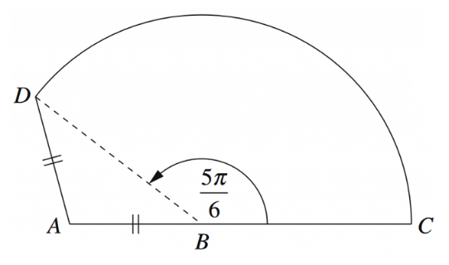
ABCD represents a garden. Points ABC lie on a straight line and $AB=AD=3$ m.
  - Show that $∠DAB=$ $\frac{2π}{3}$
$$∠DBA=π-\frac{5π}{6}=\frac{π}{6} (angles on a straight line)$$
$$∠BDA=∠DBA=\frac{π}{6} (angles opposite equal sides of isosceles triangle)$$
$$∠DAB=π-\frac{π}{6}-\frac{π}{6} \left(angle sum of a triangle\right)$$
$$=\frac{2π}{3}$$

  - Find the length of BD.
Using cosine rule
$$BD=\sqrt{3^{2}+3^{2}-2\left(3\right)\left(3\right)\cos{\frac{2π}{3}}}$$
$$=\sqrt{27}$$
$=3\sqrt{3} m$
  - Hence find the area of the garden.
$$Area ΔABD=\frac{1}{2}\left(3\right)\left(3\right)\sin{\frac{2π}{3}}=\frac{9\sqrt{3}}{4}$$
Area of sector $=\frac{1}{2}r^{2}θ=\frac{1}{2}{\left(\sqrt{27}\right)}^{2}\left(\frac{5π}{6}\right)$
$$=\frac{45}{4}π m^{2}$$
Area of garden $ABCD=\frac{9\sqrt{3}}{4}+$ $\frac{45π}{4}$ $=$ $\frac{9\sqrt{3}+45π}{4}$ $m^{2}$

- 2008 HSC Advanced Band 5
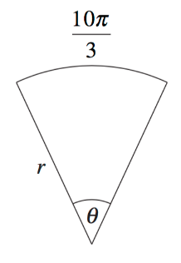
The diagram shows a sector with radius $r$ and angle $θ$ where $0≤θ≤2π$. The arc length is $\frac{10π}{3}$.
  - Show that $r≥\frac{5}{3}$
$$rθ=\frac{10π}{3}$$
$$θ=\frac{10π}{3r}$$
As $0≤θ≤2π$
$$0≤\frac{10π}{3r}≤2π$$
$$\frac{10π}{3}≤2πr$$
$$\frac{5}{3}≤r$$
As required
  - Calculate the area of the sector when $r=4$
$$A=\frac{20π}{3} units^{2}$$

- HSC Sample Question Advanced Band 5
The ratio of the radius $r$ to the arc-length $l$ is 2:5. Find the area of the sector in terms of $r$.
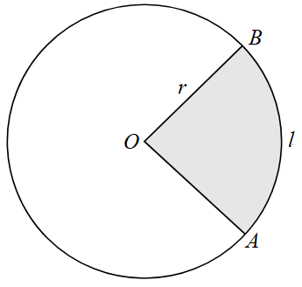
By definition, radian is the ratio of arc-length to radius.
$$∴θ=\frac{l}{r}=\frac{5}{2}$$
$$A=\frac{1}{2}r^{2}\left(\frac{5}{2}\right)$$
$$A=\frac{5r^{2}}{4}$$

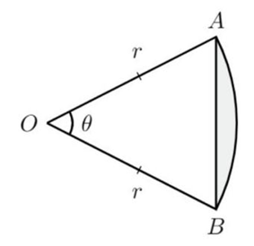
- The shaded region is called a segment. Prove that its area is given by the formula
$$A=\frac{1}{2}r^{2}\left(θ-\sin{θ}\right)$$

Area of triangle: $\frac{1}{2}$ $r^{2}\sin{θ}$
Area of sector: $\frac{1}{2}$ $r^{2}θ$
Area of segment = Sector – Triangle
$$=\frac{1}{2}r^{2}θ-\frac{1}{2}r^{2}\left(\sin{θ}\right)$$
$$=\frac{1}{2}r^{2}\left(θ-\sin{θ}\right)$$

- 2009 HSC Advanced Band 5
The triangle $ΔAOB$ is inscribed inside a circle of radius 2 cm. The area of the triangle is $\sqrt{3}$ cm².
  - Find two possible values of $θ$.
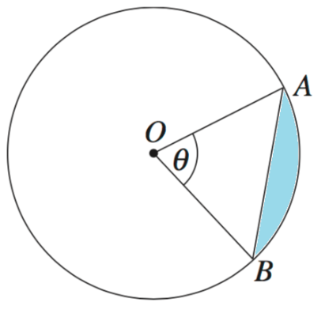
  - Suppose that $θ=$ $\frac{π}{3}$, find the exact perimeter of the minor segment $OAB$.
$$a) using A=\frac{1}{2}ab\sin{C}$$
$$\sqrt{3}=\frac{1}{2}\left(2\right)\left(2\right)\sin{θ}$$
$$∴θ=\frac{π}{3} or\frac{2π}{3}$$

$$b) using cosine rule, straight line AB=2$$
$$arc length AB=\frac{2π}{3} cm$$
$$∴P=2+\frac{2π}{3} cm$$

